

**American International University- Bangladesh**

**CSC 3222: Web Technologies**

**CO1 and CO3 Evaluation**

**Project Report**

**Fall 2019-2020**

**Project Title: Event Organizer**

**Section: F**

|  |  |
| --- | --- |
| Student Name | Student Id |
| Hedaetul Islam | **17-33554-1** |
| Fokrul Islam Bhuiyan | **17-33535-1** |
| Faisal Abdullah | **17-33471-1** |
| Kazi Fakhrul Abedin | **17-33594-1** |

**Introduction:**

*Nowadays, when people plan for an event (such as a wedding ceremony, birthdays, anniversaries, etc) they often face many problems. People who are looking for an organizer for their event, in the beginning, they get puzzled about where to go first or how to find a better organizer. If their residences are far from the organizer’s office, distance seems like a big issue then. The next problem is, a client cannot get full and clear details of an event organizer. For this reason, they don't know what type of service they are going to receive and if they get a bad service which is not even close to their desired one, they cannot say anything against the service. The client may need to change the event date if an organizer gives a time schedule and it clashes with another. Sometimes it is so difficult for them. Serious problem is, overspending or not having enough money; often they ended up spending more than their actual budget.*

**Background Study:**

*In an existing system, the person has to visit the particular office for inquiry. This manual process is quite complex. Everything has to be done manually. The event management system of the existing solution has to keep records of events manually. There are some solutions to this project. We will try to mention it below. At present, there are a lot of social media in the world. So, people can find the organizers in social media. So, It makes easier to solve the problems.*

*From social media, people can know the details of an organizer. Nowadays some organizer gives demo details about them when clients go to their page. A client can also imagine the maximum amount of target budget from the details. So, it is helpful for the clients.*

*In addition, the Organizer team increases it’s team for the client. For this reason, the client can manage their time schedule properly.*

[*http://www.anantabd.net/*](http://www.anantabd.net/?fbclid=IwAR2A_G6jks9_yH_kmtSJ9K_4cdrV6kbb22JGDLPpcxJWpwOLcy3fI6Px1WE)

[*http://www.bdweddingplanners.com/*](http://www.bdweddingplanners.com/?fbclid=IwAR0U8SqU9DuzbKfopO82n8mX5Gnm8WEGYV7aWs2TkCCQGzCfTYNVpFlmnnM)

**Requirement Analysis:**

1. **User Category:**

There are 3-types of Users here. They are:

* *Admin*
* *Customer*
* *Vendor*

1. **Feature List:**

In this project the “Admin” has the following features:

* *Can see the records of purchase confirmed, total customers, pending orders, vendors, payment transactions.*
* *Can update criteria, package other options.*
* *Tracking the order system done by admin.*
* *Admin can approve vendor registration.*
* *All comments, remarks, feedback, problems are evaluated by admin.*

In this project the “Customer” has the following features:

* *Can register and login to the system.*
* *The event type is searchable.*
* *Can send emails or messages to the manager.*
* *Several event packages which can be chosen by the customer.*
* *Similar packages can be shown.*
* *For advance booking customer can contact the manager.*
* *Many types of the payment system.*
* *Can see the review of a merchant.*
* *Searching by package, price, timing, place, particle items.*
* *Only registered customers get notification about new updates and bookings.*
* *Customers can report a problem.*
* *Unregister customers can see our services on our website.*
* *Customers can complete registration within 2 minutes.*
* *When customer search event type auto-suggestion helps him to find it.*
* *He will be Session out after 10 mins.*

In this project the “Vendor” has the following features:

* *A vendor can add his records.*
* *A safe transaction with the vendor.*
* *A vendor can update his records.*
* *He will be Session out after 10 mins.*

**Design:**

Draw an entity diagram of your project here.

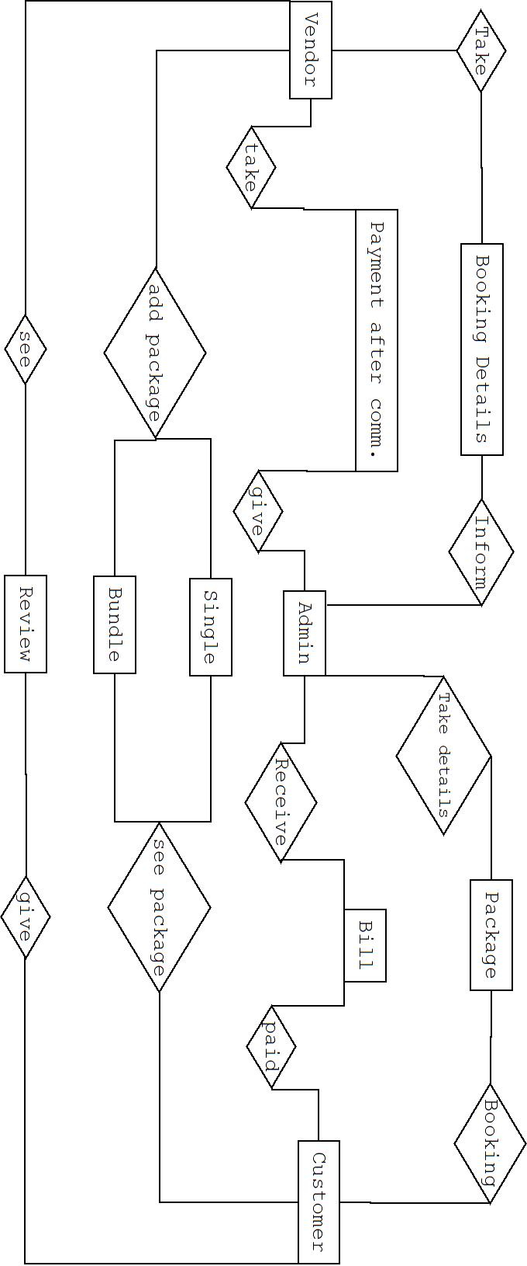

**Tools Used:**

To develop this project, we have used the following:

* PHP
* Js
* MySQL
* HTML
* CSS

**System Images against the Specification:**

**Services:** *Here, clients can see our offered services.This services can be single or bundled.*

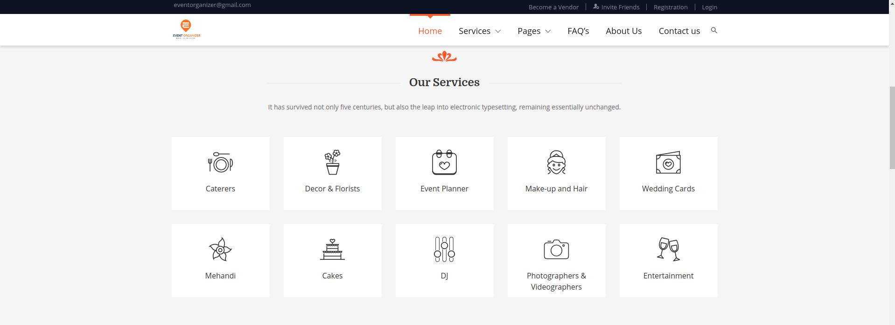

**About Us:** *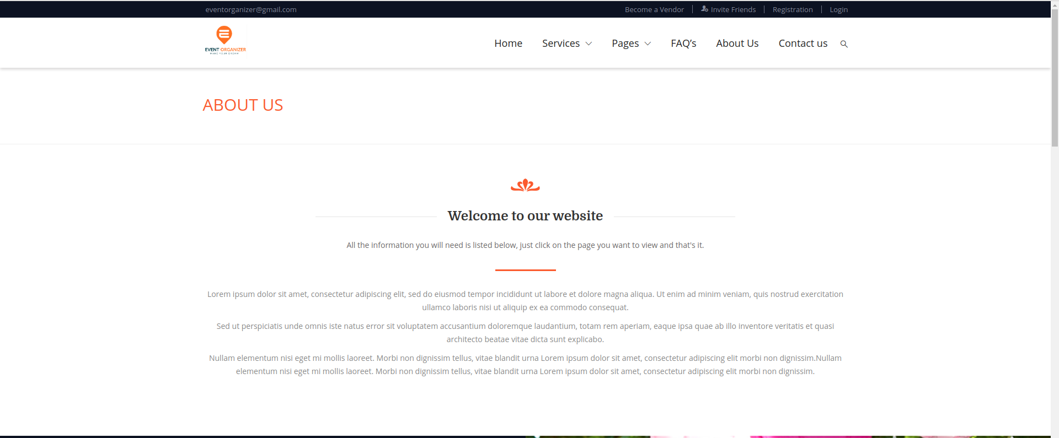This section will show company information with welcome greetings.*

**Footer:***Here user will see company’s contact info and some social media link of the company.*



**Contact:***This will show the geographical location of the company's office.*

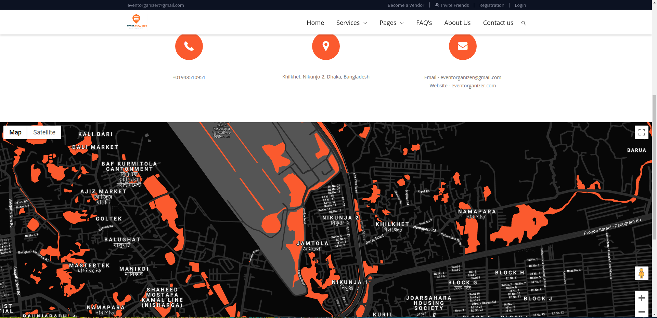

**FAQ:** *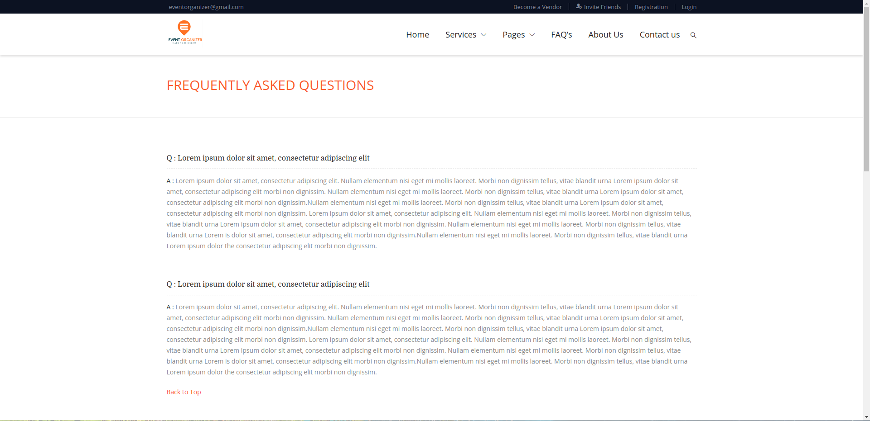FAQ section which will show frequently asked questions of clients towards the company.*

**Blog:***This is basically a feedback page where clients can share their experiences with our company.*

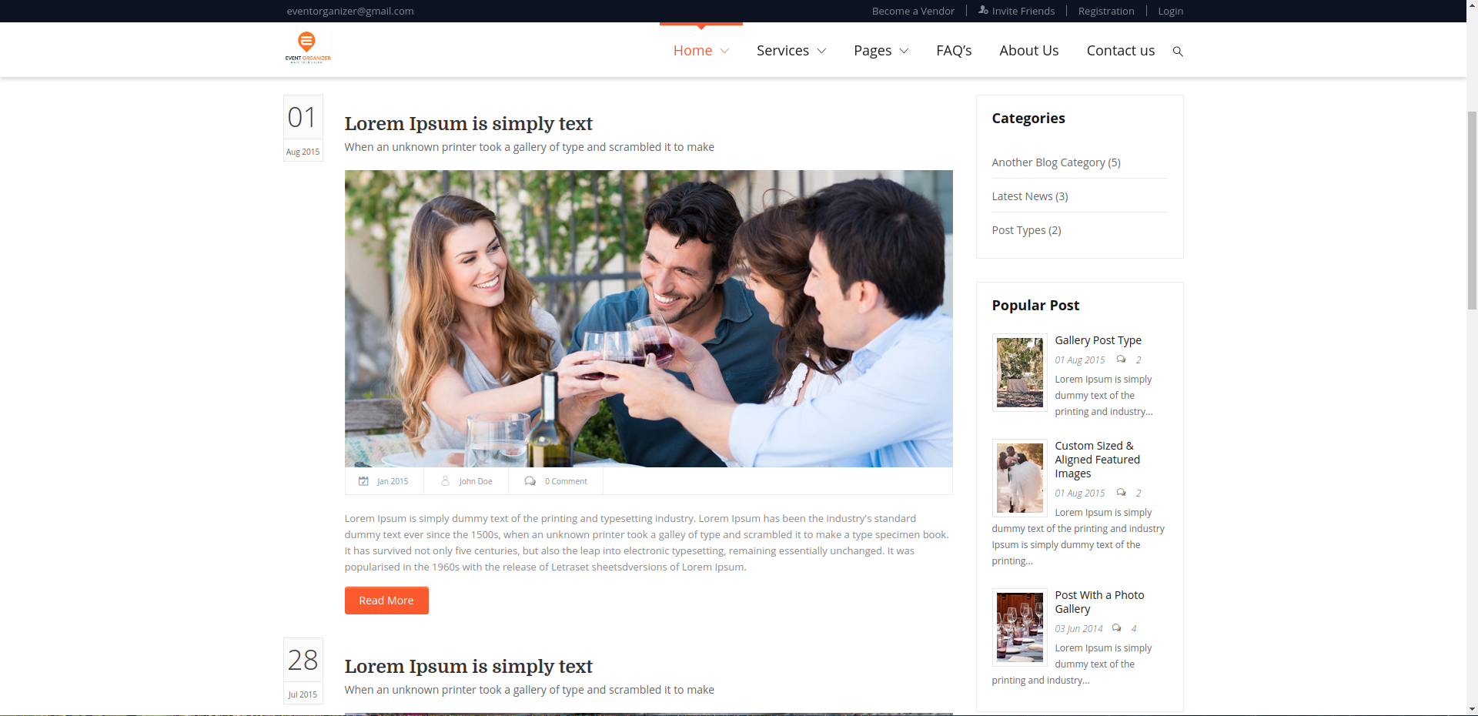

**Booking:** *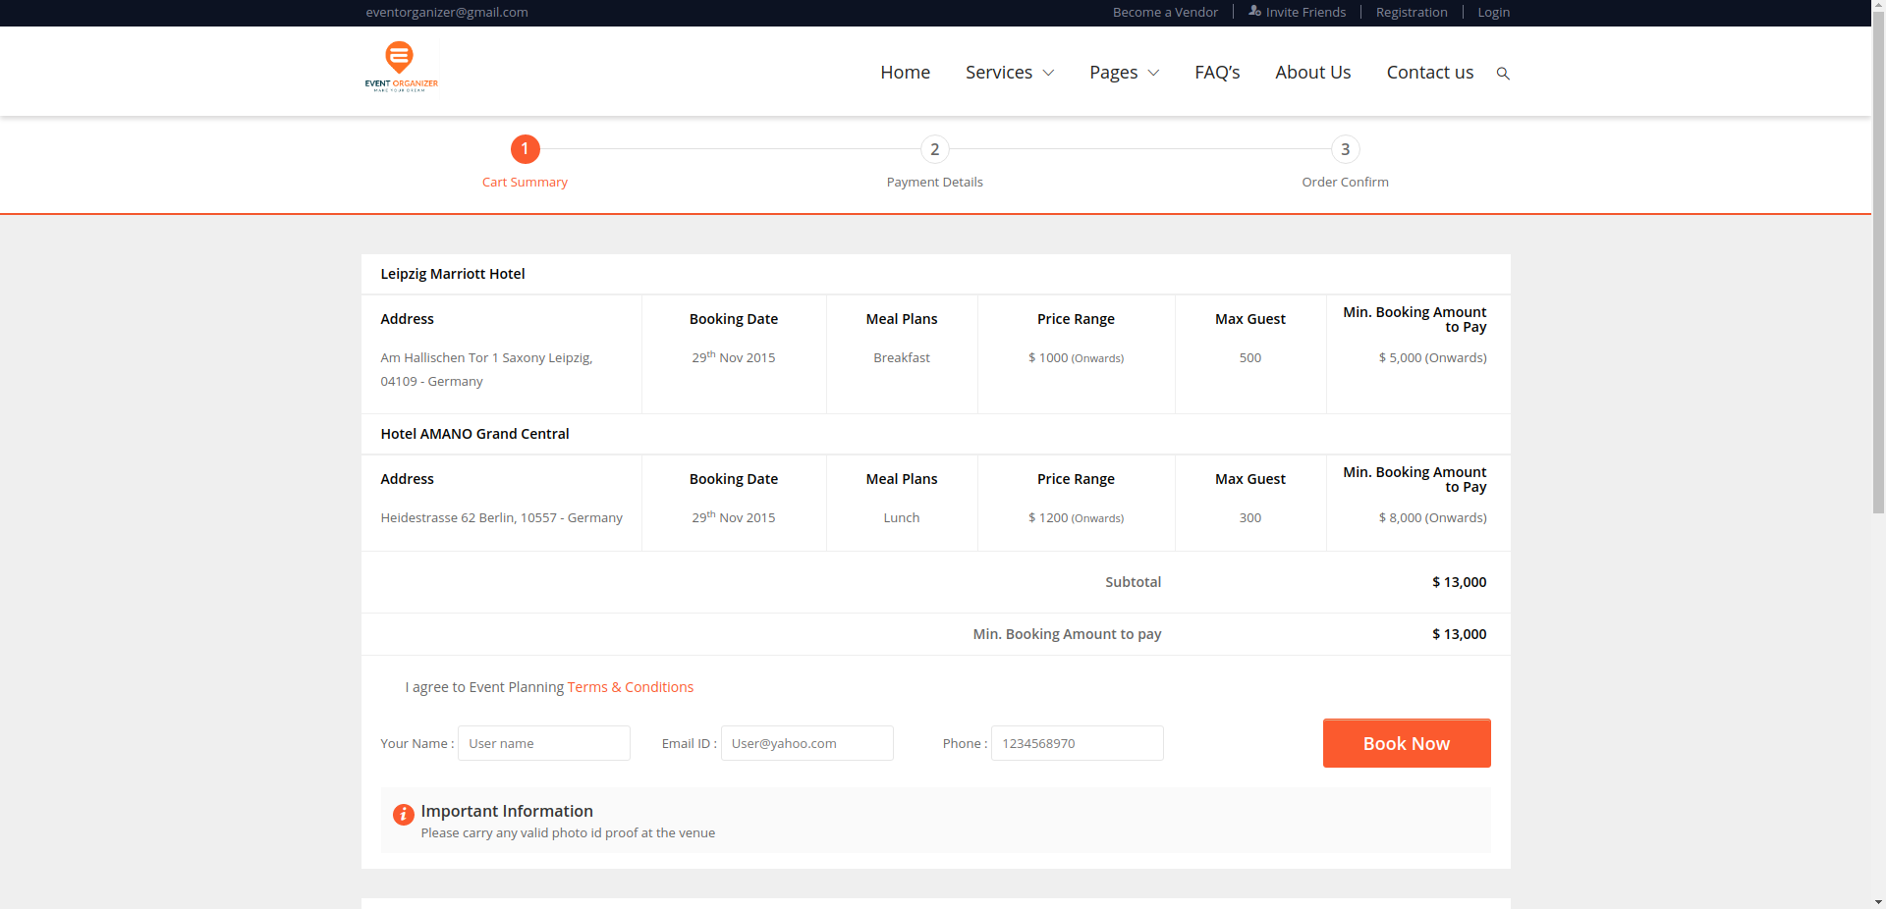It is the main booking page where clients will book their event to be organized. Here they can also see all the price details.*

**User Profile:** *Current user information will be shown here.*

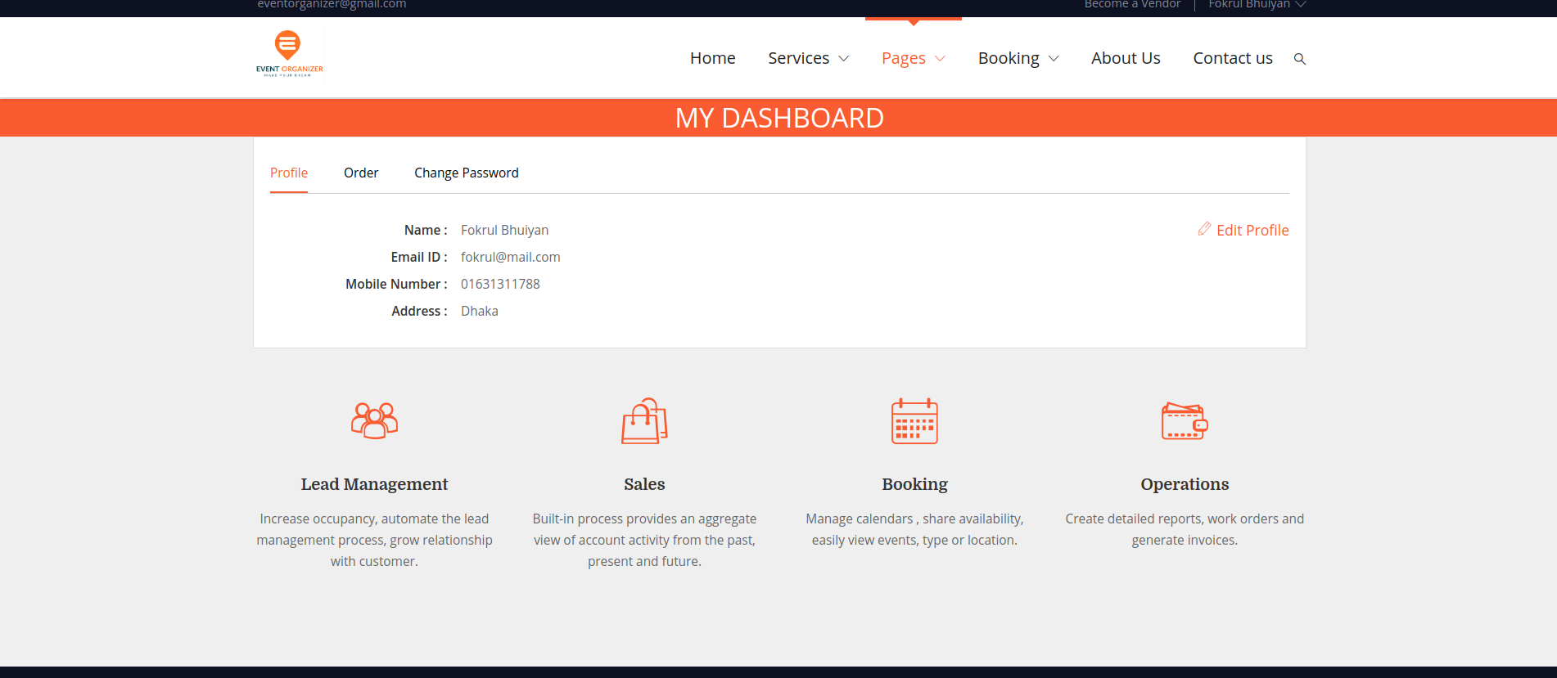

**Impact of this Project:**

*Some problems can be handled by the existing solution. But still, there are many lacking and issues exist while planning an event. Our proposed solution will help people who are planning for a successful event.*

*Our proposed system is an online event management system software project that will serve the functionality of an event manager. The system will allow registered users to log in and new users are allowed to register on the application. The project will provide most of the basic functionality required for an event. It will allow the user to select from a list of event types. Once the user enters an event type (Marriage, Birthday, etc), the system will display some packages to choose for the event. As many service providers will be connected with the system, clients can be able to find their expected organizer/service provider with complete details for their event. It will also allow the user to select the date and time of the event. All this data keep in the database and the user is given a receipt number for their booking. This data is then sent to the event managers team and they may interact with the manager via inbox conversation/email and contact data stored in the database.*

**Limitations and Possible Future Improvements:**

* *This system can be used only in Bangladesh as it is not worldwide available.*
* *Clients can not directly communicate with the vendor.*
* *Company is not responsible regarding vendor’s experience.*
* *In starting only clients of Dhaka city can use the system after that our service will be available throughout the country as part of future improvements.*

|  |  |  |  |  |  |
| --- | --- | --- | --- | --- | --- |
| **CO1 and CO3 Evaluation: Project Report Evaluation** | | | | | |
| **Project Proposal**  **(5)** | **Background**  **Study**  **(5)** | **Requirement Analysis**  **(5)** | **Entity**  **Diagram**  **(5)** | **System Images**  **against the**  **Specification (5)** | **Total (25)** |
|  |  |  |  |  |  |
|  | | | | | |